Digital Photography II
Stop Motion Animation

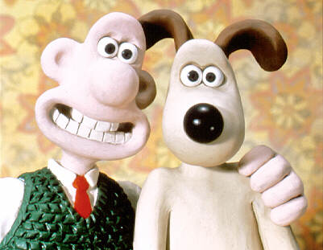
Summary
Students will you use digital photos to create a stop motion animation.
Targets
- To create a series of still photos
- To use those stills to create a stop motion animation
Final Product
- The final animation will be posted on the wiki
- NO CONTACT SHEET NEEDS TO BE MADE
The Details
- Brainstorm ideas for an animation
- Collect all of the necessary props
- Set up the scene and camera
- Take a photo, move the prop, take the photo, move the prop, etc.
- You will need 100-200 shots for a 30 second animation
- When you have all of the shots save them in one folder.

