Import an image sequence to create your animation
To begin, import the image sequence into iPhoto by drag-and-drop. Then open iMovie and follow these steps:
- It's convenient to have the image sequence as your last import in iPhoto,because then you'll immediately find them under that same folder name in iMovie's image browser.
- In iMovie, create a New Project, call it (e.g.) "StopMotion"
- In iMovie, open the media browser,
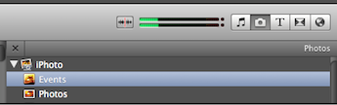
- In this example, I select 77 images from the iPhoto library, shown in the media browser:
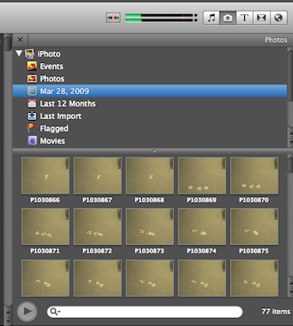
- Drag the images to the new project:
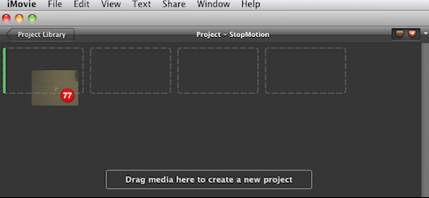
- The process may take a while:
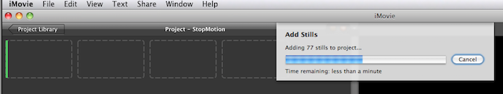
- Select all images in the new project, and select Window > Clip Adjustments. Type in a duration such as 0.05 and check the box for "Apply to all stills":
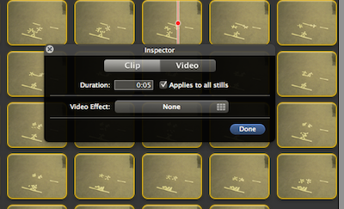
Click Done.
- What if you can't get the duration short enough? It may be that your version of iMovie doesn't allow you to go below a clip duration of 0.1s. That's too slow for a smooth movie with fast-moving objects. The work-around for this involves some arithmetic: say you want the shortest frame in your animation to be 0.025 seconds long. Then set its duration to the minimum of 0.1s for now, and scale up the durations of all other frames in your animation by the corresponding factor of 4. You will then be exporting a movie that looks four times slower than desired. However, we'll fix this with one additional step at the end. Let's first complete the settings for exporting the movie.
- With all images still selected, select Window > Cropping, Ken Burns and Rotation:
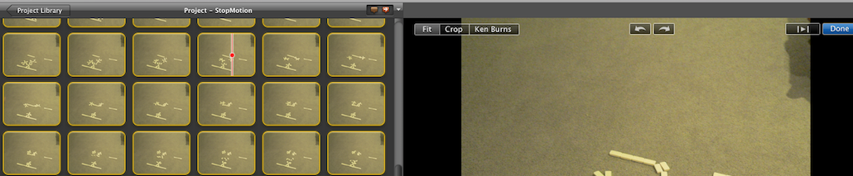
Select "Fit".
- Now you will likely want to fine-tune the animation by adjusting the frame duration of individual images. To do that, select the frame (or frame range) you want to change. Enter a modified frame delay, but make sure not to apply this to all stills. For the delay, you can enter the format 1:23 (seconds separated by a colon from milliseconds), or 0.2 (to specify fractions of a second). Press Enter or Done to make the change stick!
- Optionally, add sound effects by dragging from the sound browser
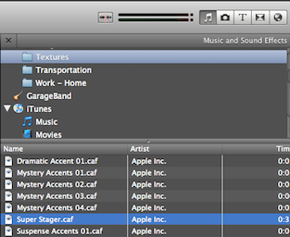
to the desired frame in the project:
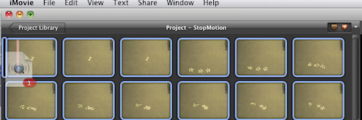
If your movie isn't at the desired speed yet (because you had to scale the frame durations up as described above), skip this and the next step.
- To change audio settings (e.g., fade out the sound), click on the audio clip and select Window > Audio Adjustments:
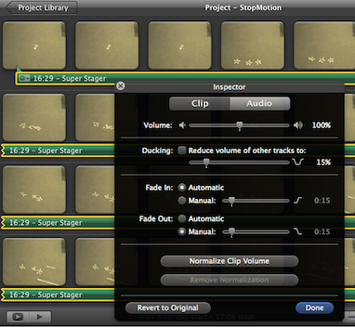
- Under the Share menu, choose Export using Quicktime (adjust preferences if needed):
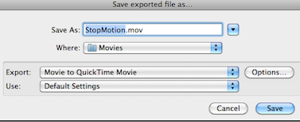
- Now come the optional steps to speed up the exported movie. Create another New Project and go to File > Import > Movie... to re-import your newly created movie back into iMovie.
- Drag the imported movie to the new project, select it and choose Window > Clip Adjustments as we did earlier for the still images. But unlike before, you'll now see an entry "Speed" (depending on the format of the imported movie, you may need to click a "convert" button before you can change this setting). A slider will appear that lets you speed up the movie:
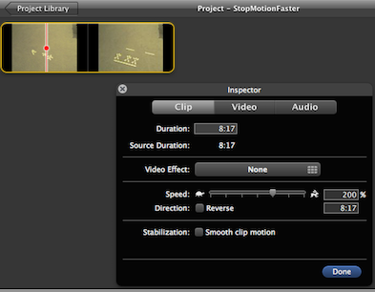
- Finally you can go back to Share > Export using Quicktime and export the movie at the new speed.

