Digital Photography A
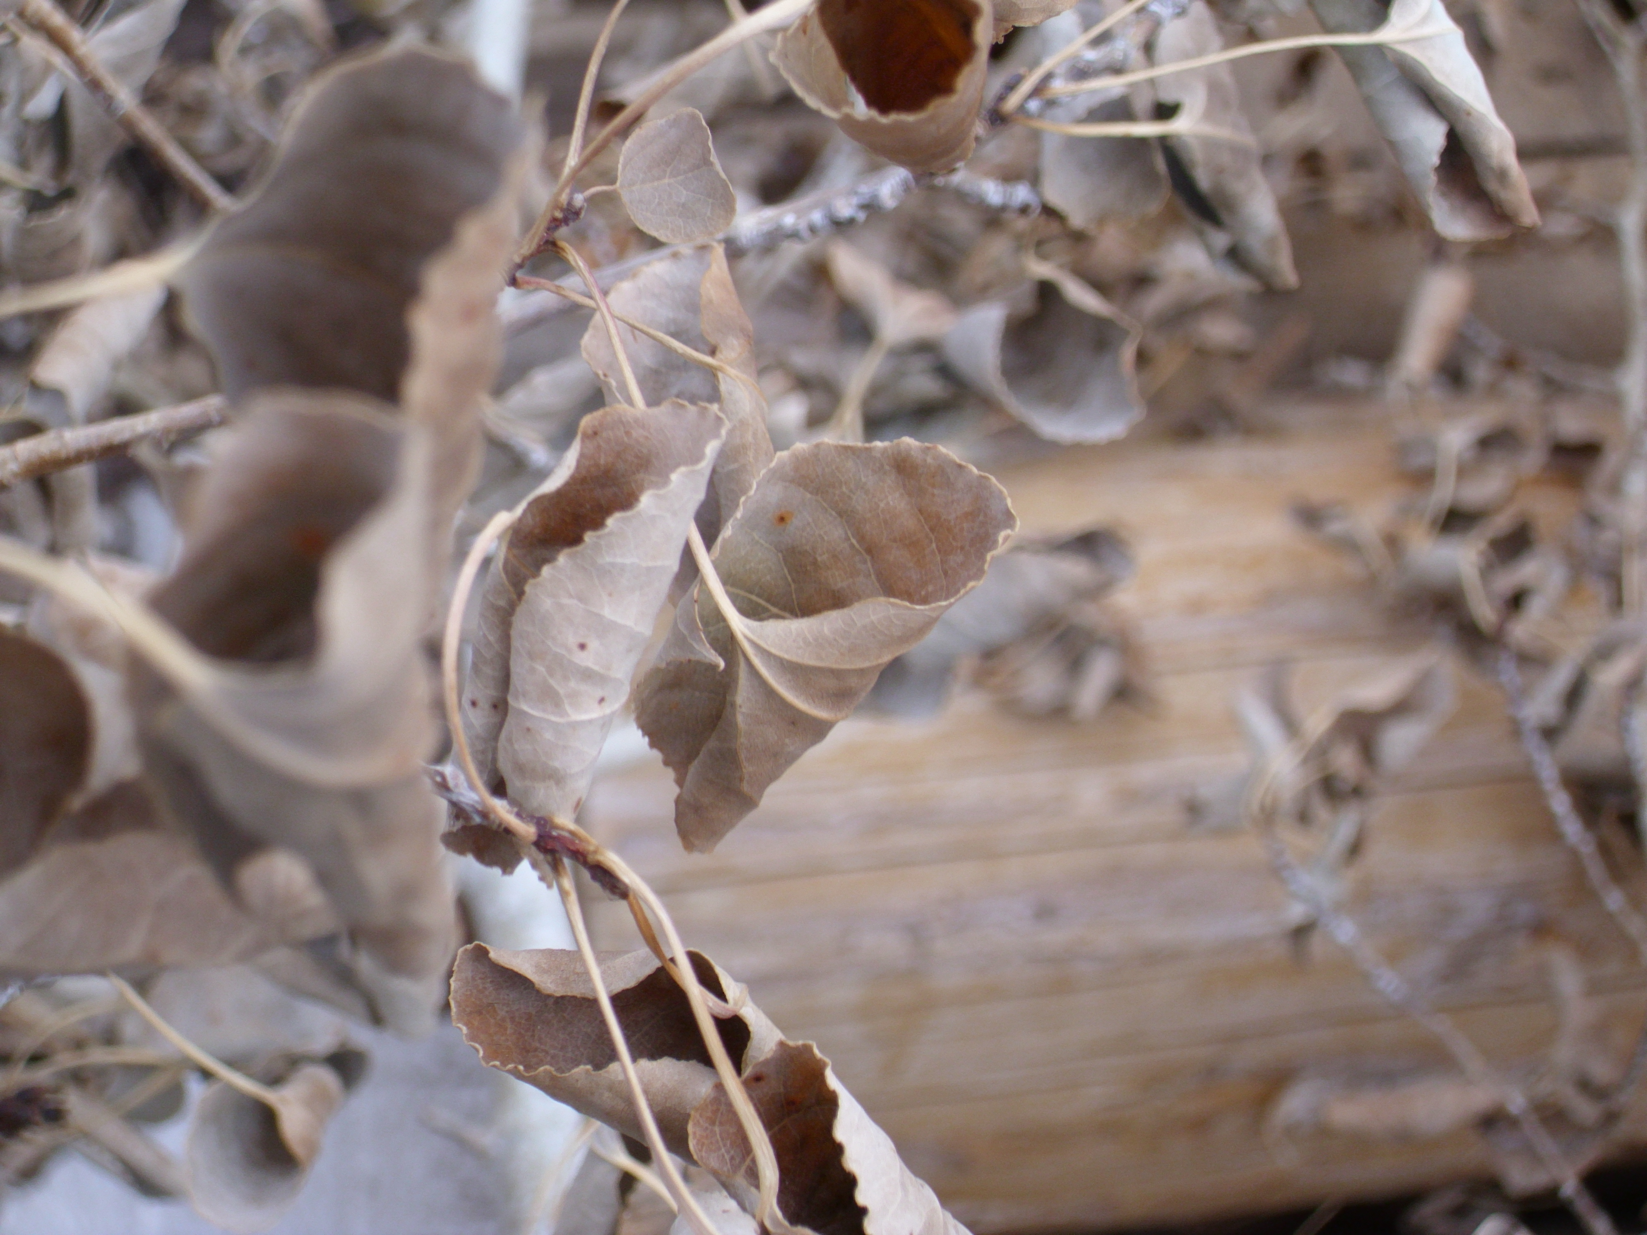
Scavenger Hunt

Summary
To practice using your camera and to learn how to turn in photographs.

Targets
- Become familiar with camera.
- Learn to download and turn in photos.
- Create a contact sheet.

Final Product
  - You will turn in a contact sheet of all of your photos.
  - The best photo will be placed on the wiki.

The Details

- Your goal is to find and take photographs of the following five items:
  - Something that is soft
  - Something brown that is not made of wood or stone
  - Something cold to the touch
  - Something that makes noise
  - Something with movable parts
- Try and find something that no one else is using
- Keep your camera in AUTO mode
- When you are finished photographing your five images, return to class immediately so that we can move on to turning in your photos.

