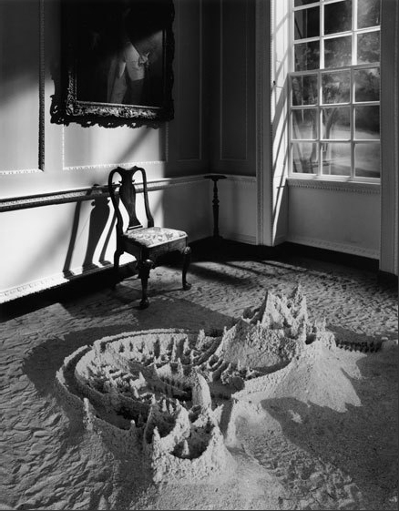
Advanced Photography
Final Photography Project
FAMOUS PHOTOGRAPHER EMULATION

Summary: For this final project you will emulate one of the famous photographers you were introduced to this semester.

Details:
- Select one of the Famous Photographers, review their “Style” of photography
- Take at least 40 photographs in the “style” of that photographer

Final Products:
- Contact sheet with at least 40 photos on wiki
- FIVE great photos on the wiki
- Type an artist statement on wiki; explain how your photographs emulate the famous photographer.

