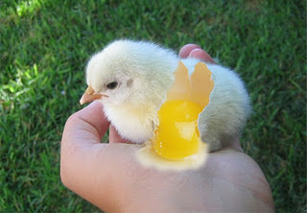
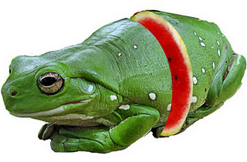
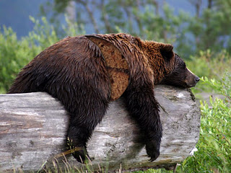
One Slice!
Your challenge:
Create something sliced! What you choose and how you slice it is up to you however your best bet is to consider matching shapes, colors, textures and contours carefully. As always, take care with selections and cuts. Craftsmanship makes all the difference!
