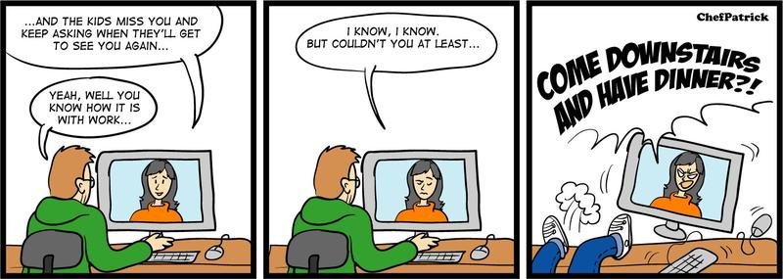
Commercial Photography

Comic Strip

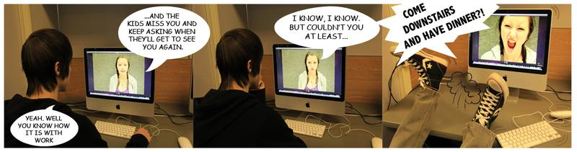
Summary
To recreate a comic strip using your own photos and photoshop.

Targets
- Emphasize the subject in a photo based on camera and subject location
- Position subjects and props to match the scene
- Use the macro feature on the camera

Final Product
  - You will turn in a contact sheet of all of your photos.
  - The original comic on the wiki
  - The Photoshopped comic on the wiki

The Details

- Find a three-four panel comic from the Internet (make sure it is school appropriate).
- Save the comic on your server
- Recreate the scenes in the comic by taking photographs of your friends in the same situations. Try to replicate the same positioning, frames, backgrounds, props, etc.
- Be sure to leave room in the frames for the text bubbles.
- You need to take extra photos for each scene, a minimum of 12 photos is required.
- Print a contact sheet.
- Create a document long enough to add all the three-four panels.
- You can alter your photos, crop, adjust levels, add filter effects, etc.
- Add the text bubbles by using the Custom Shape Tool.
- Add the text.
- Make any final adjustments that you need.
- Put the original and final comic on the wiki.

